**Cheflab_in singlemachine**

Installing Chef Server,Chef Workstation and Chef Node in single Linux Machine

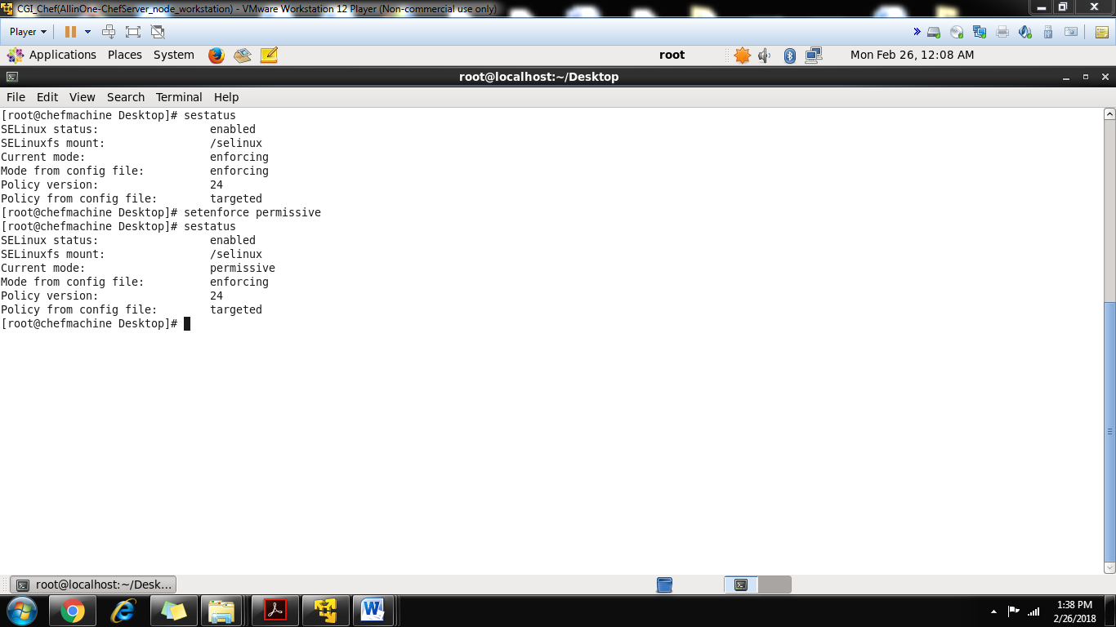

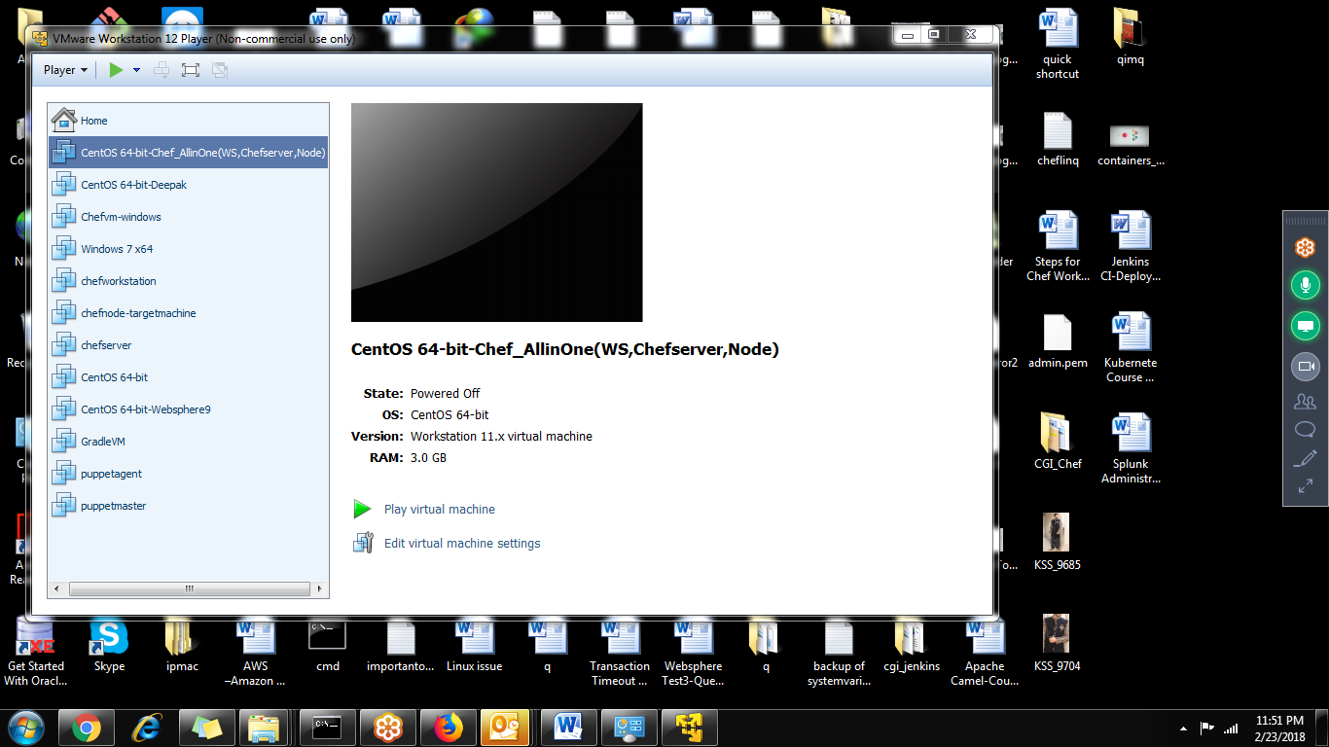

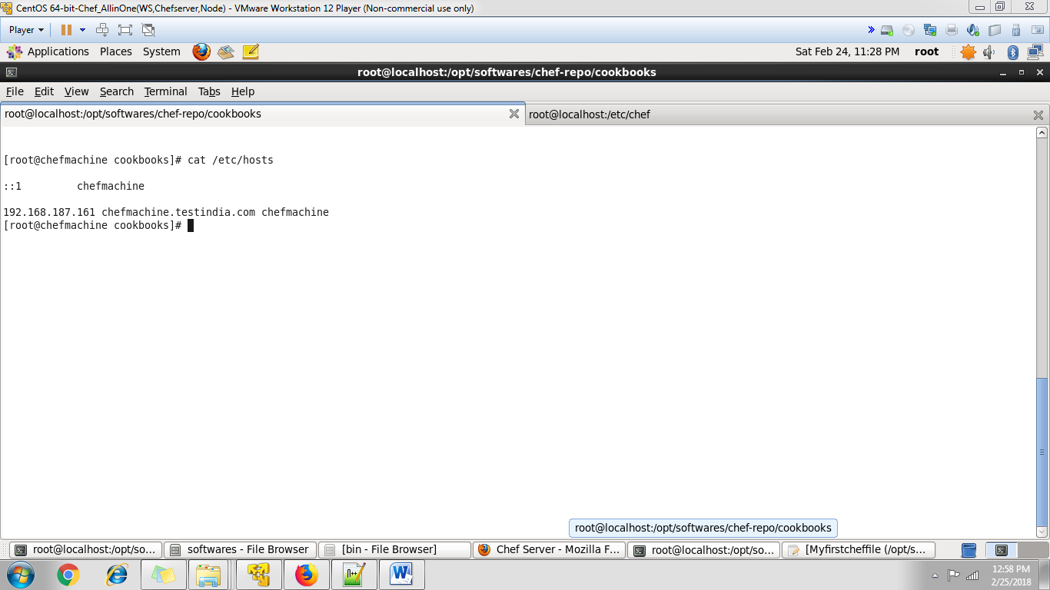

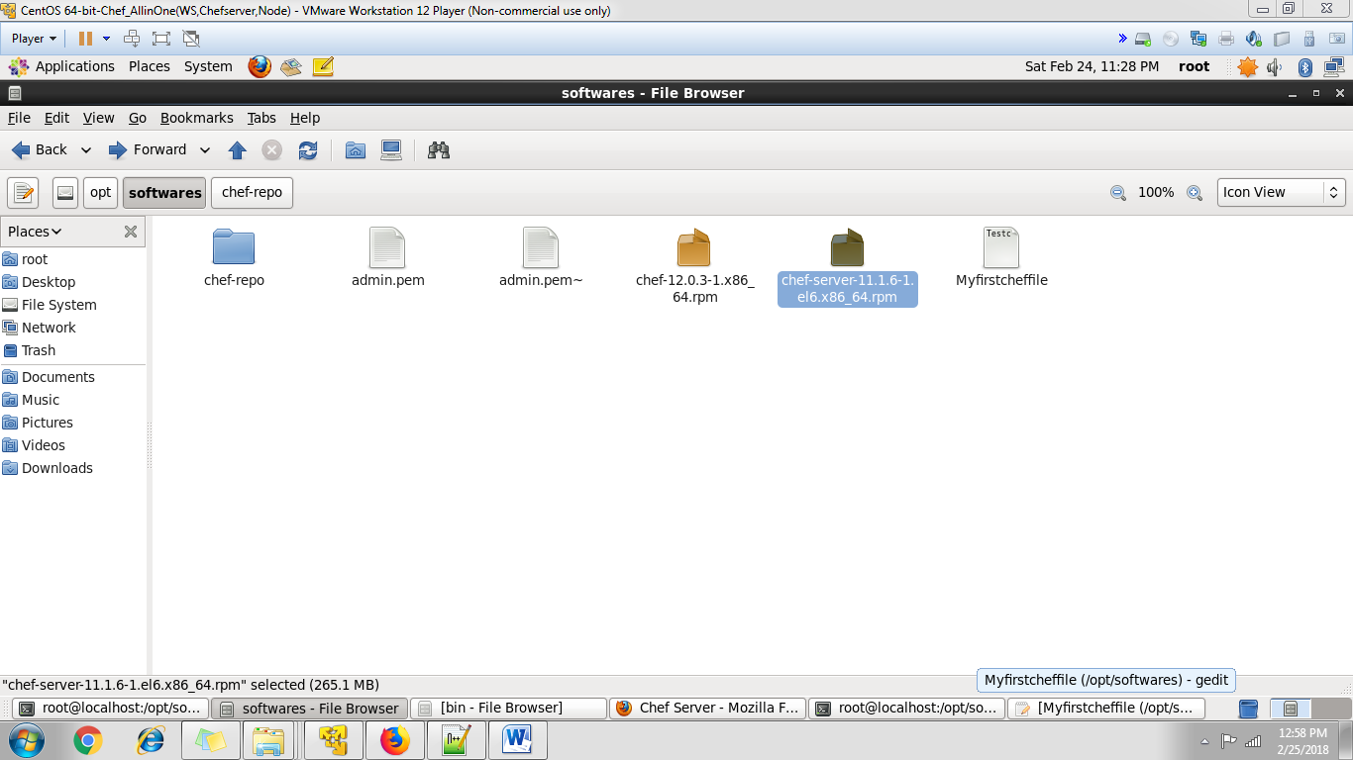

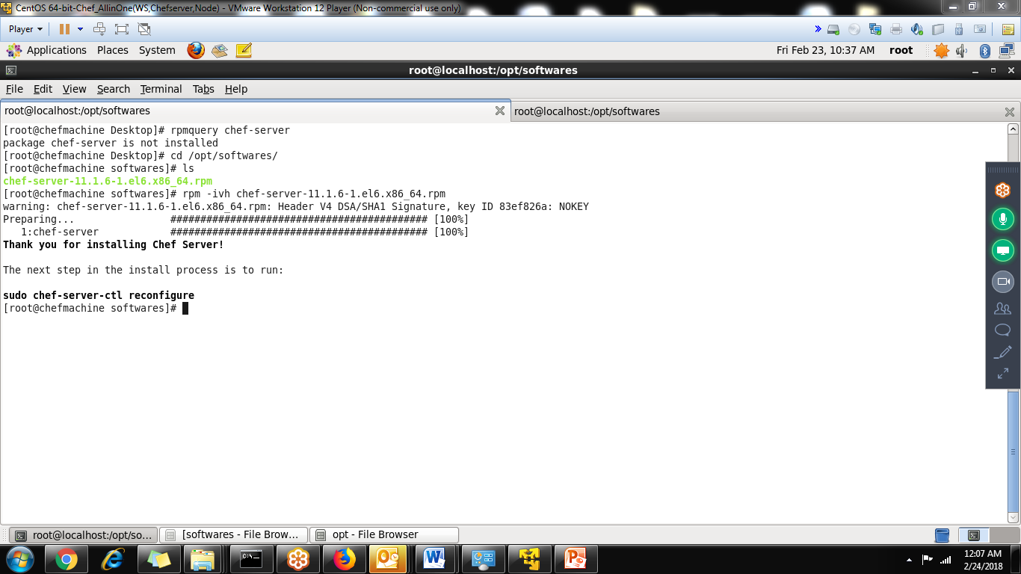

Run the command chef-server-ctl reconfigure

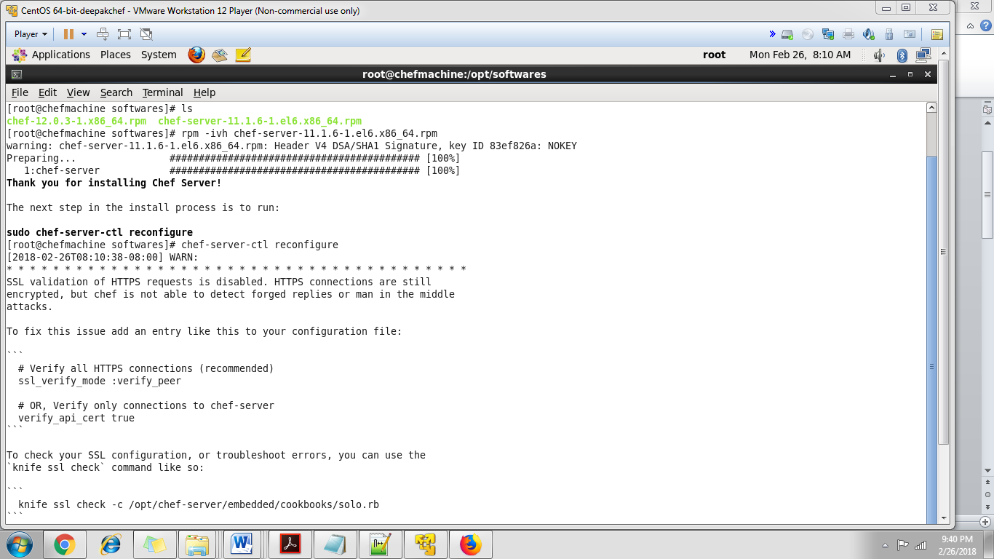

This command will take sometime

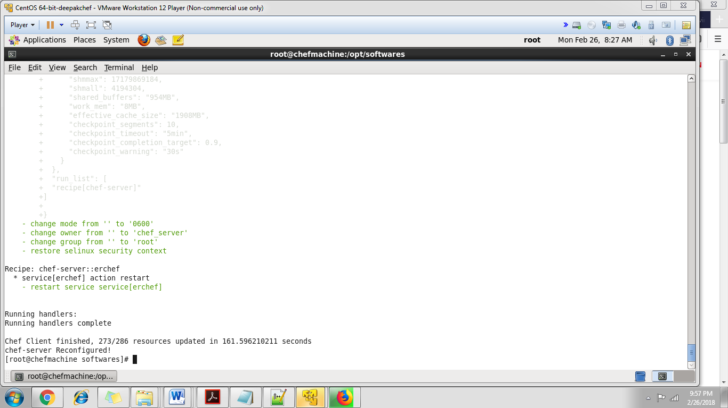

Next use the command chef-server-ctl status

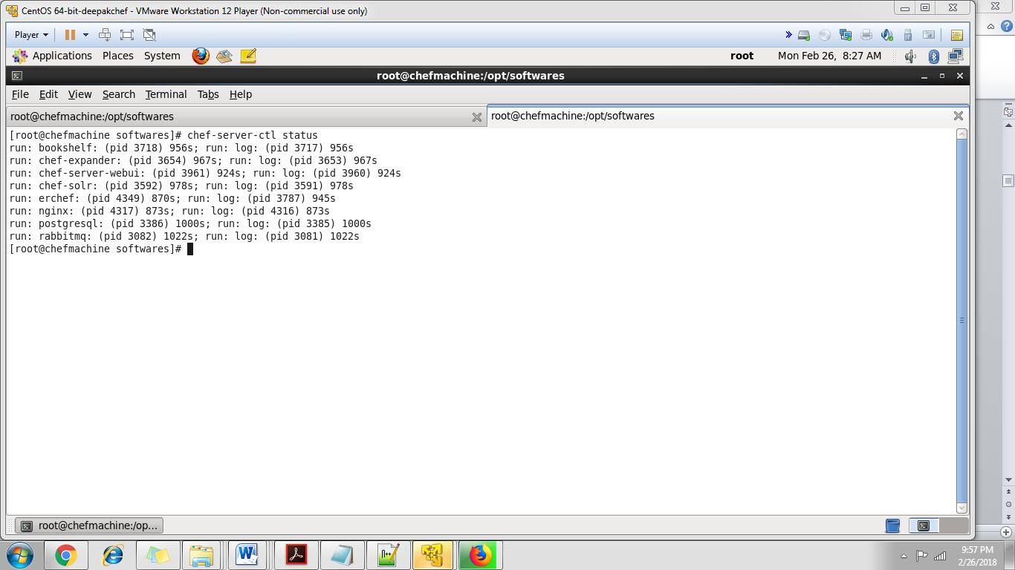

Chefserver file system

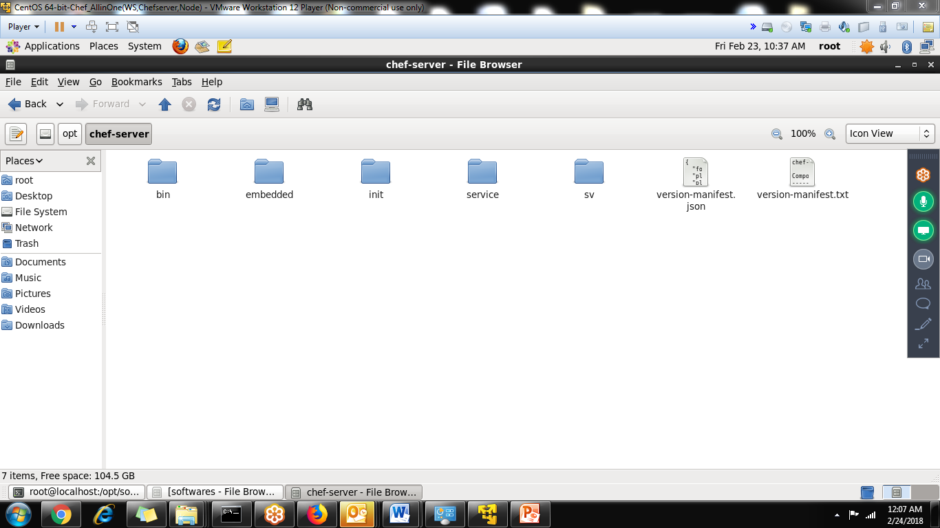

Login to chef management console

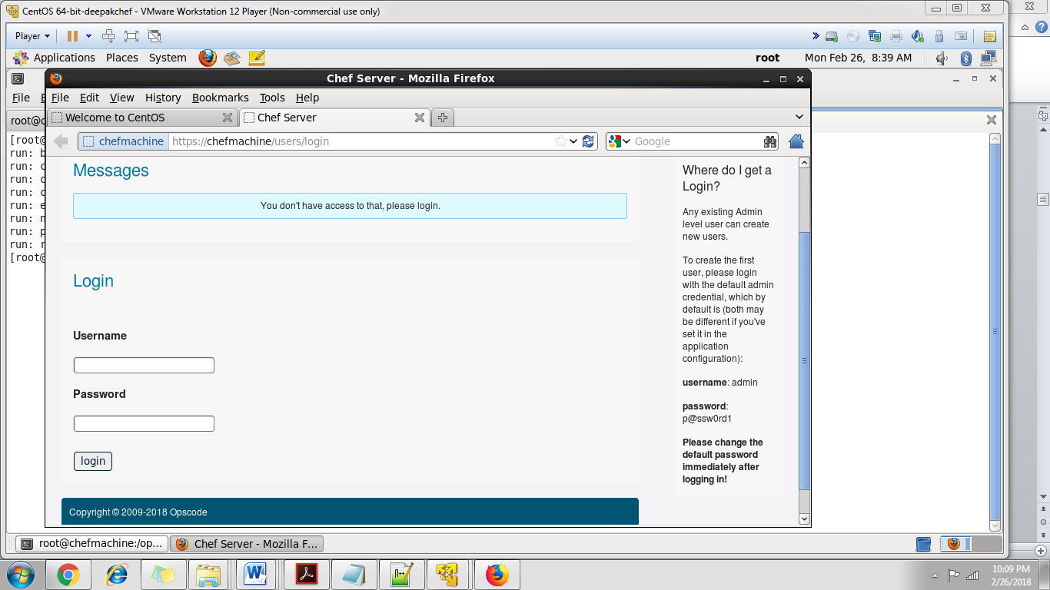

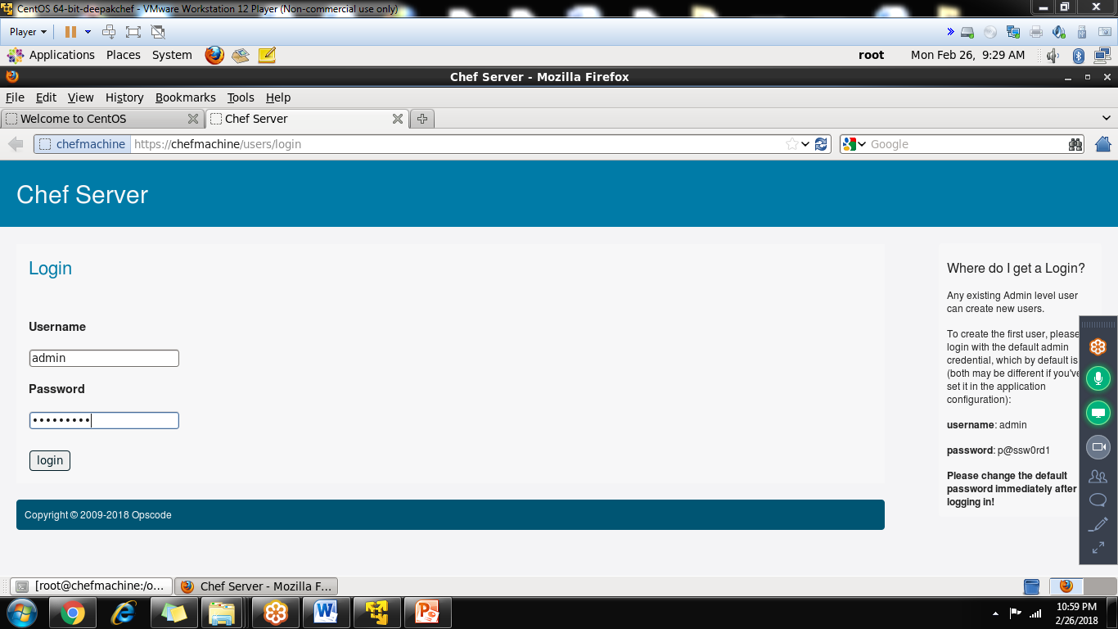

After first login with default username/password, change the password and take the copy of private key in admin.pem

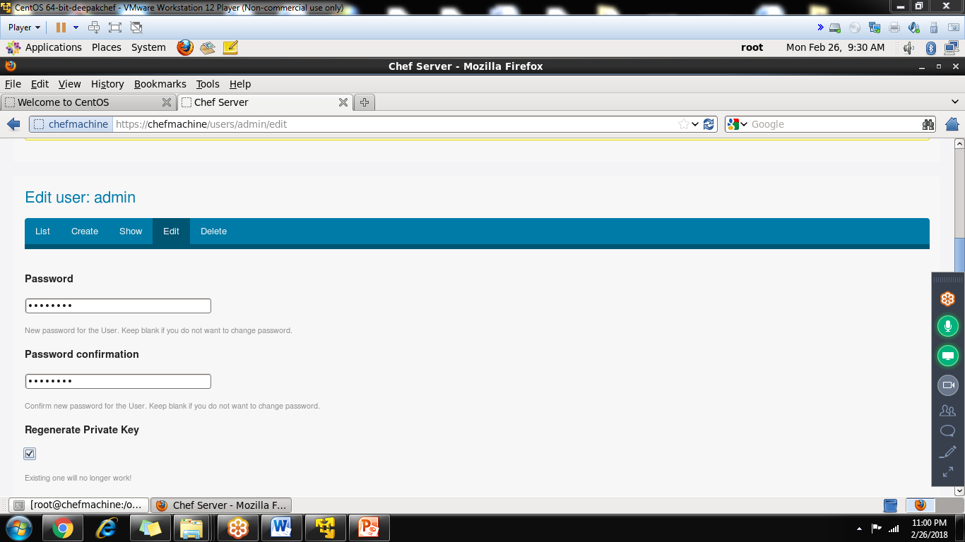

Private Key (Will not show again, Please copy!)

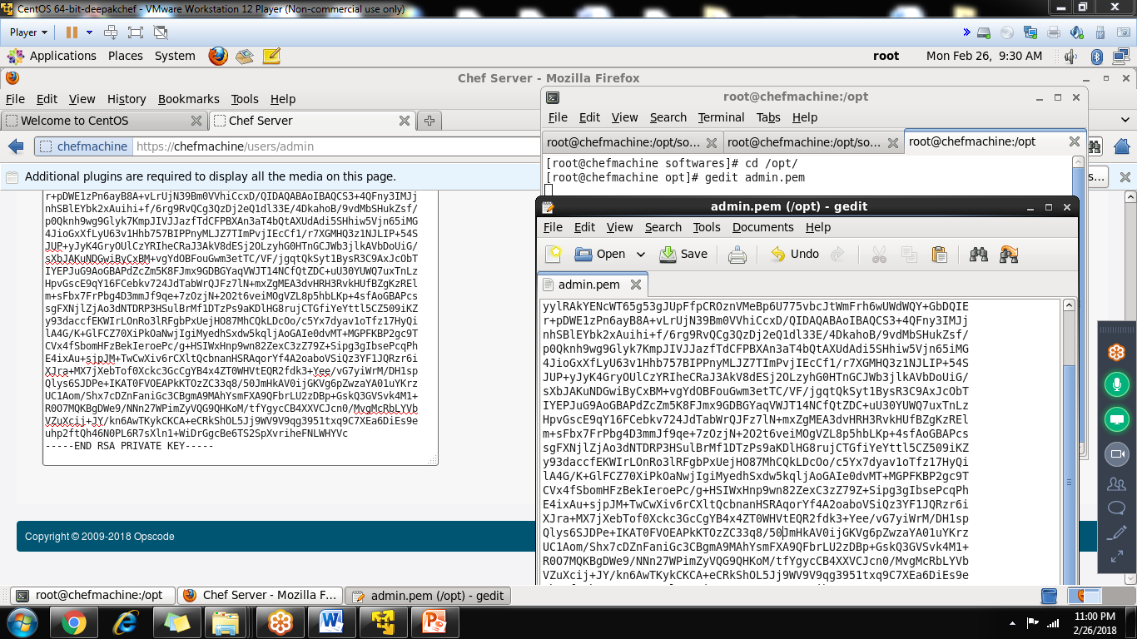

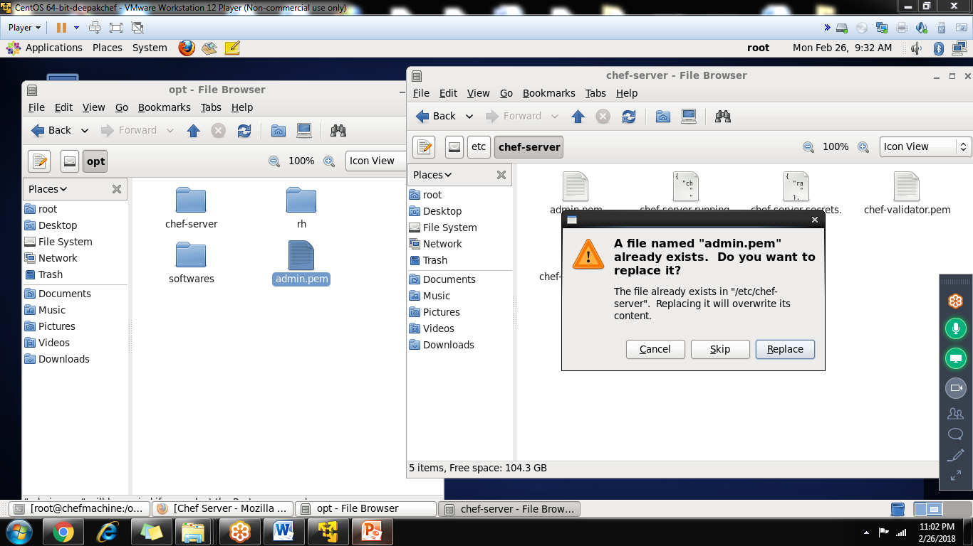

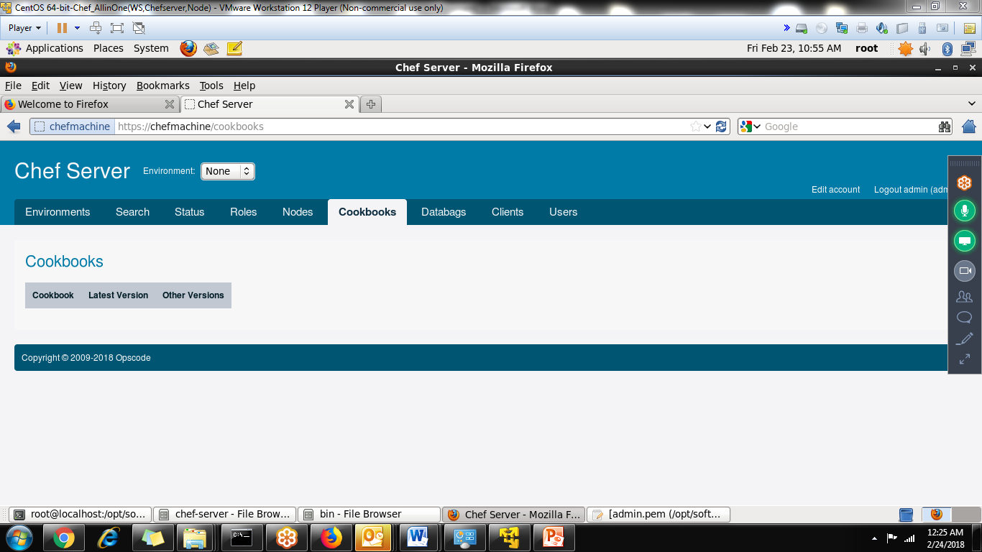

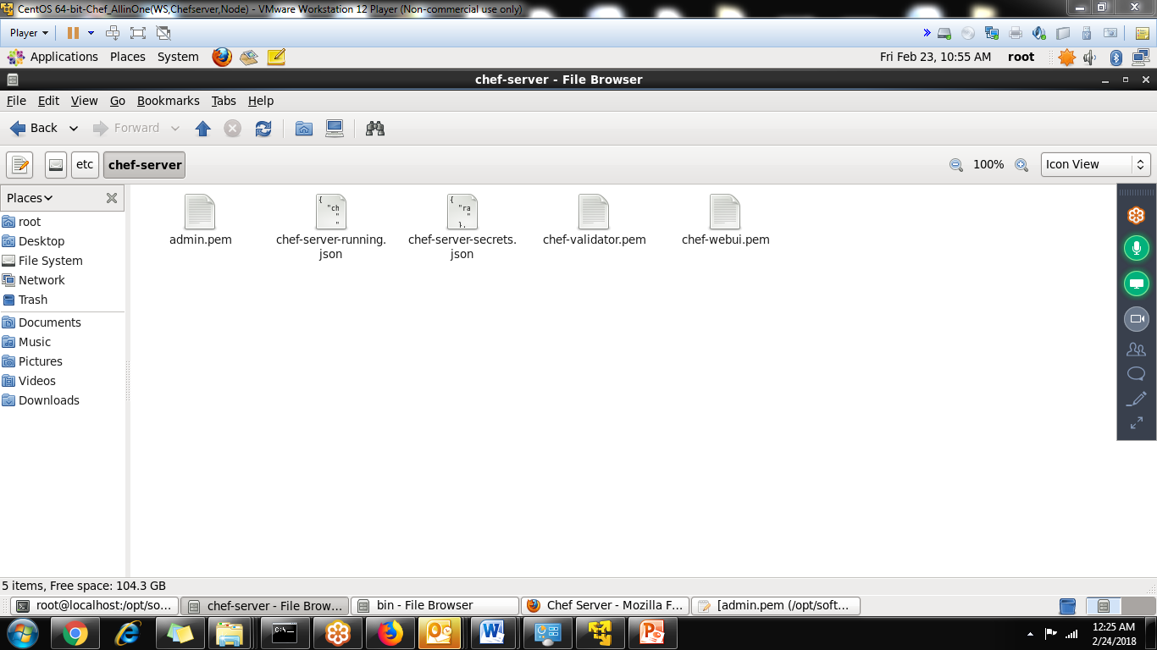

**To stop the chef-server**

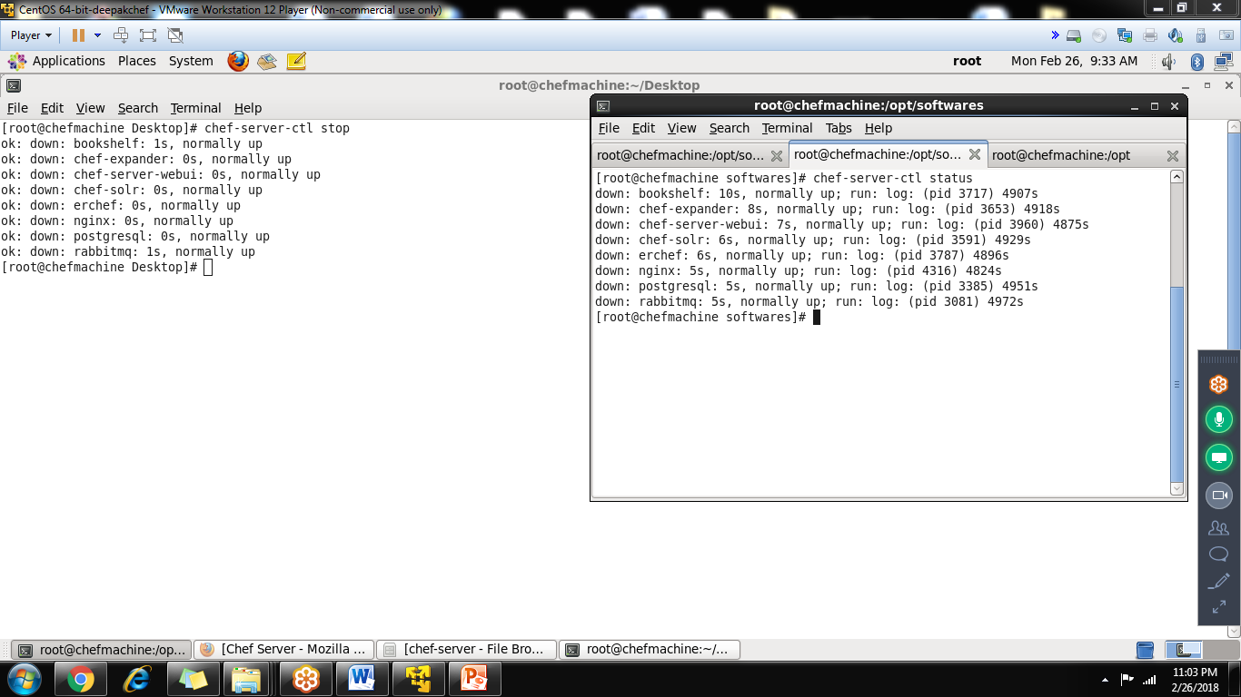

**To restart the chef-server**

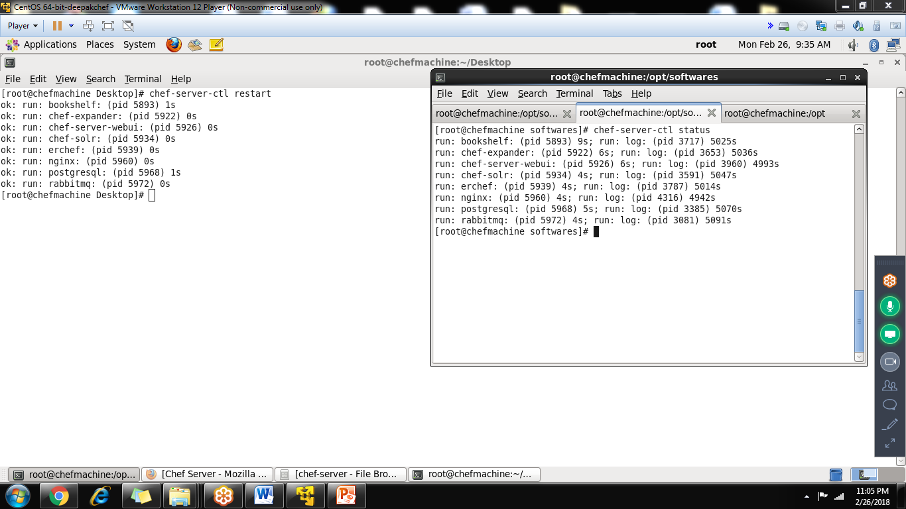

**To start the chef-server**

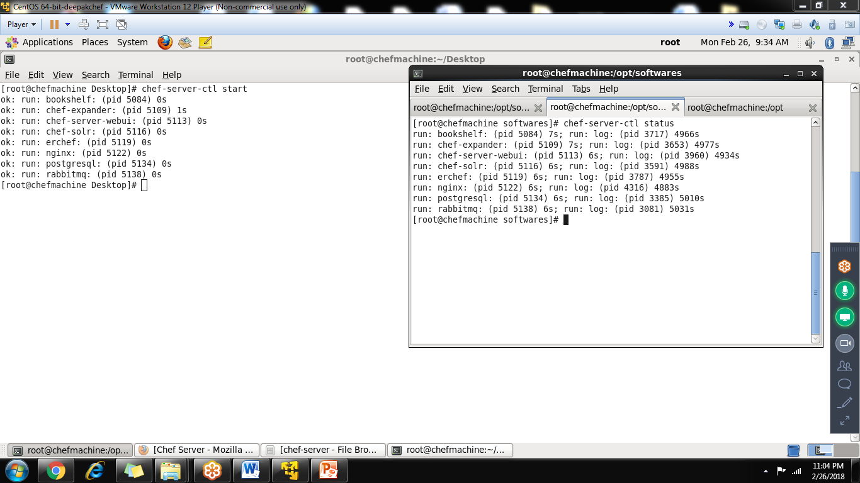

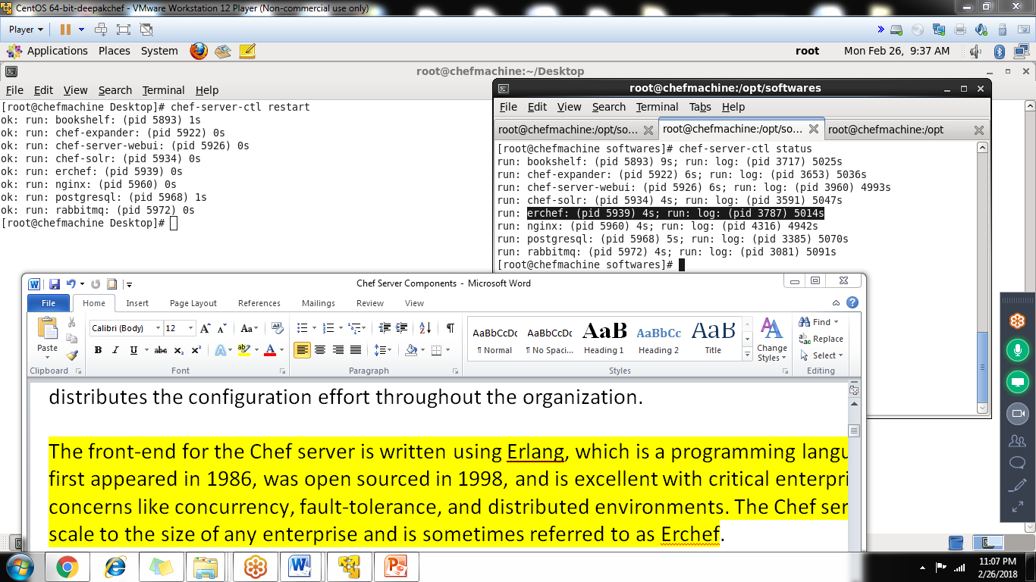

**Step-2: Chef WorkStation Installation**

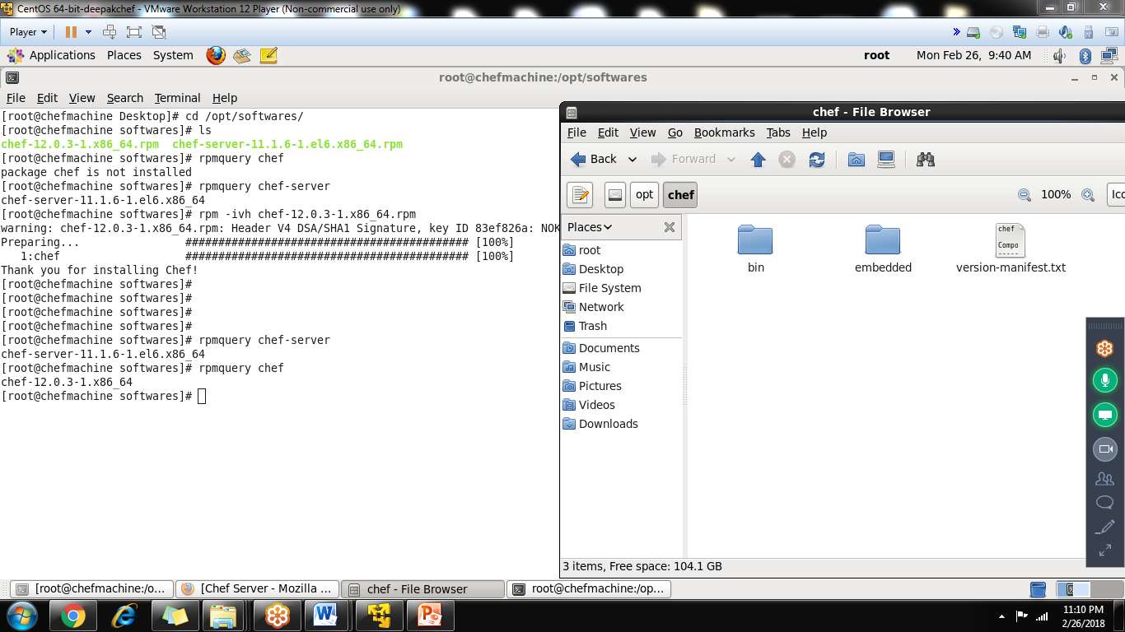

Creating the chef repo using git

Install the git

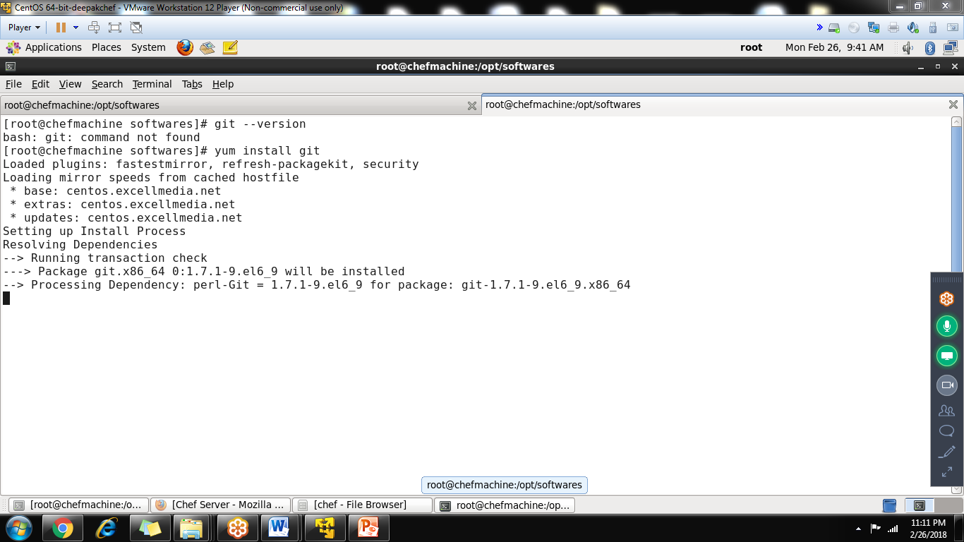

Pre-defined url for chef-repo

git clone git://github.com/opscode/chef-repo.git

git clone git://github.com/opscode/chef-repo.git

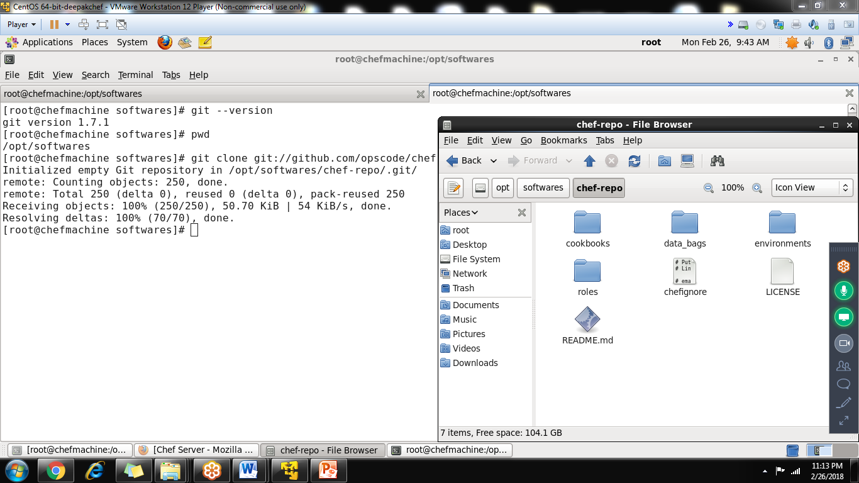

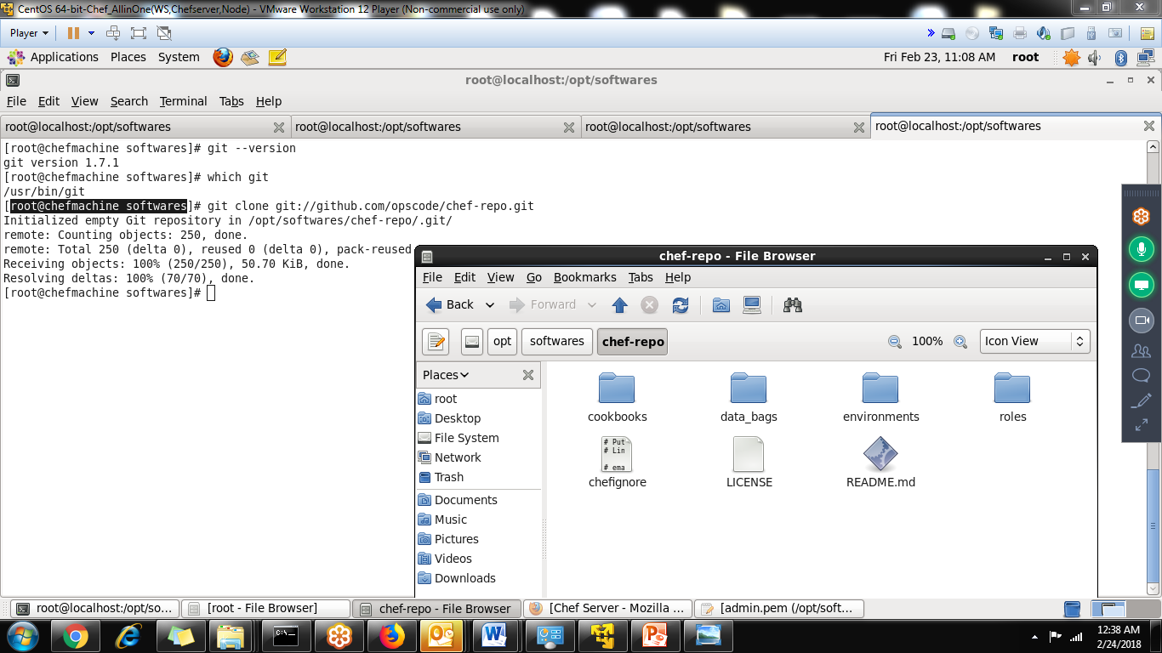

Chef repository location: /opt/softwares/chef-repo/

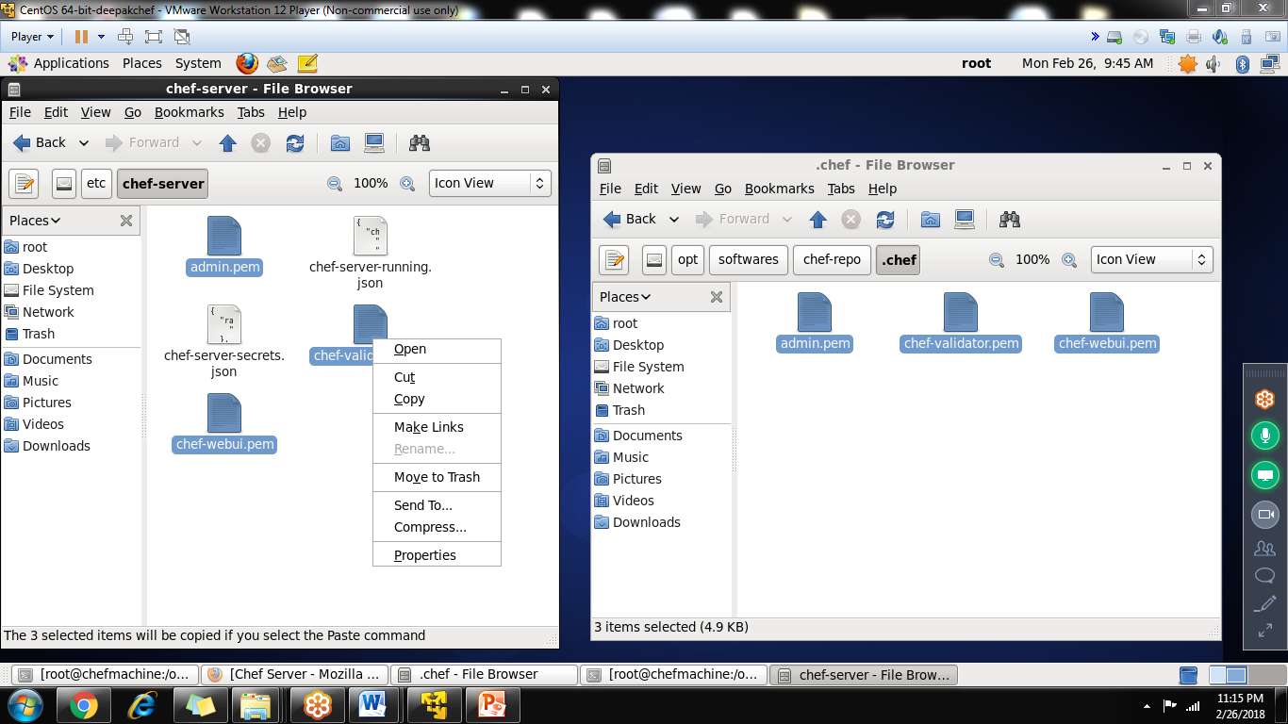

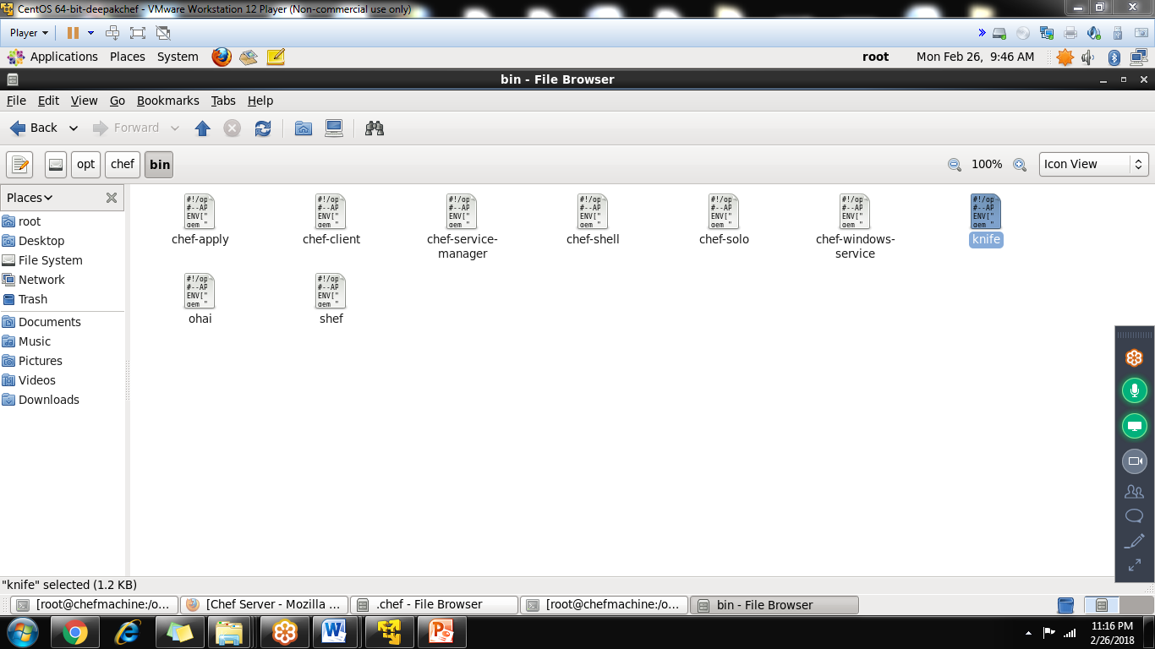

Create a user in linux(example: india1)

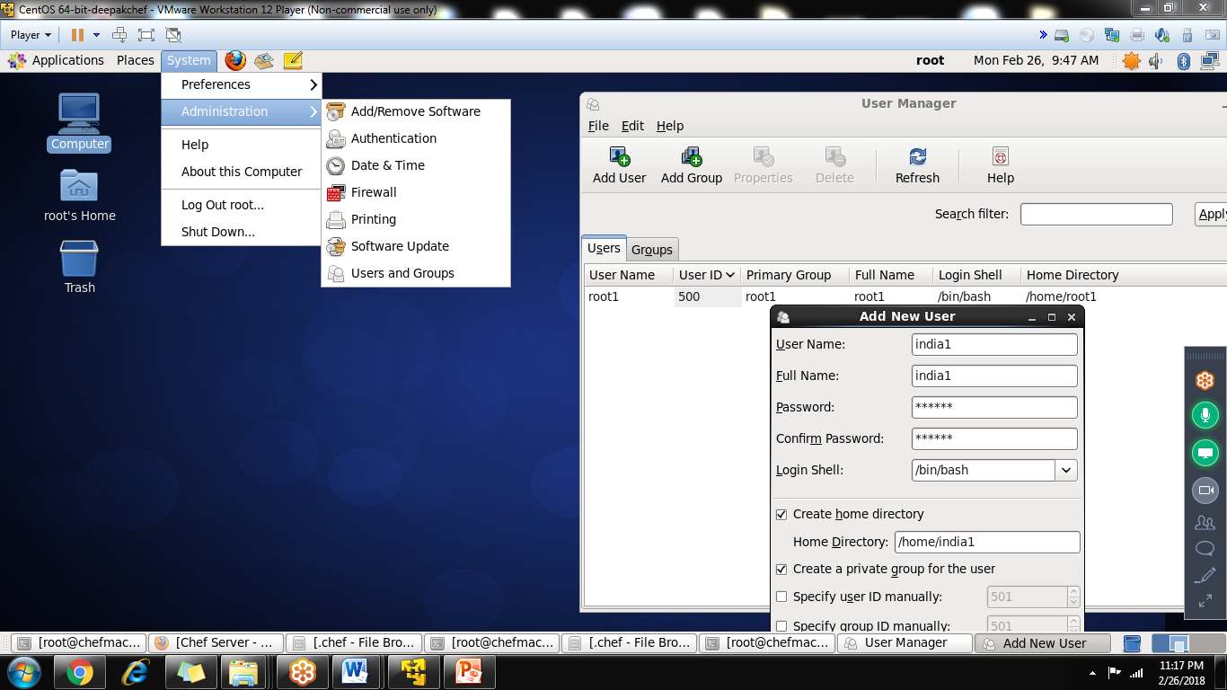

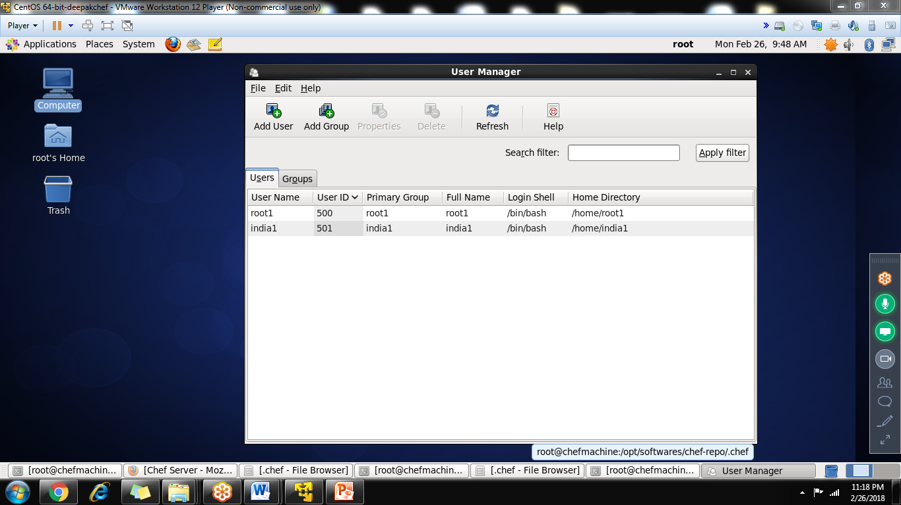

To integrate workstation to chef server using

Knife configure –i

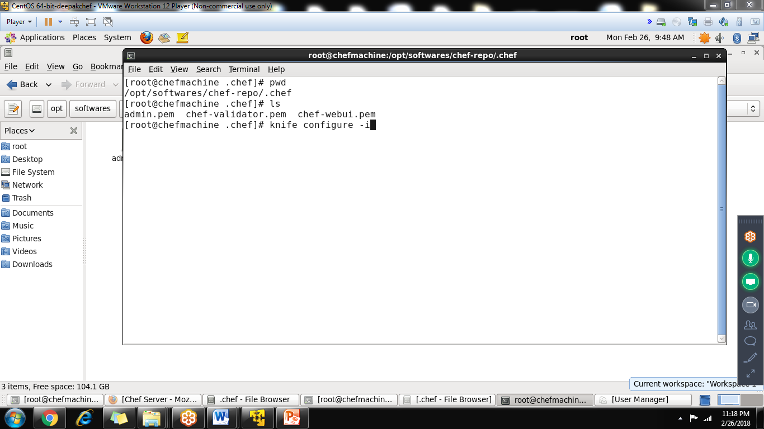

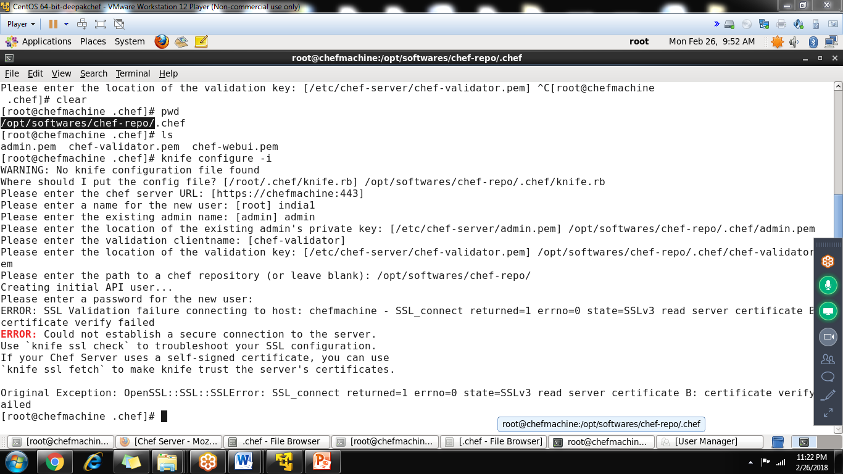

First time somes it will be failed

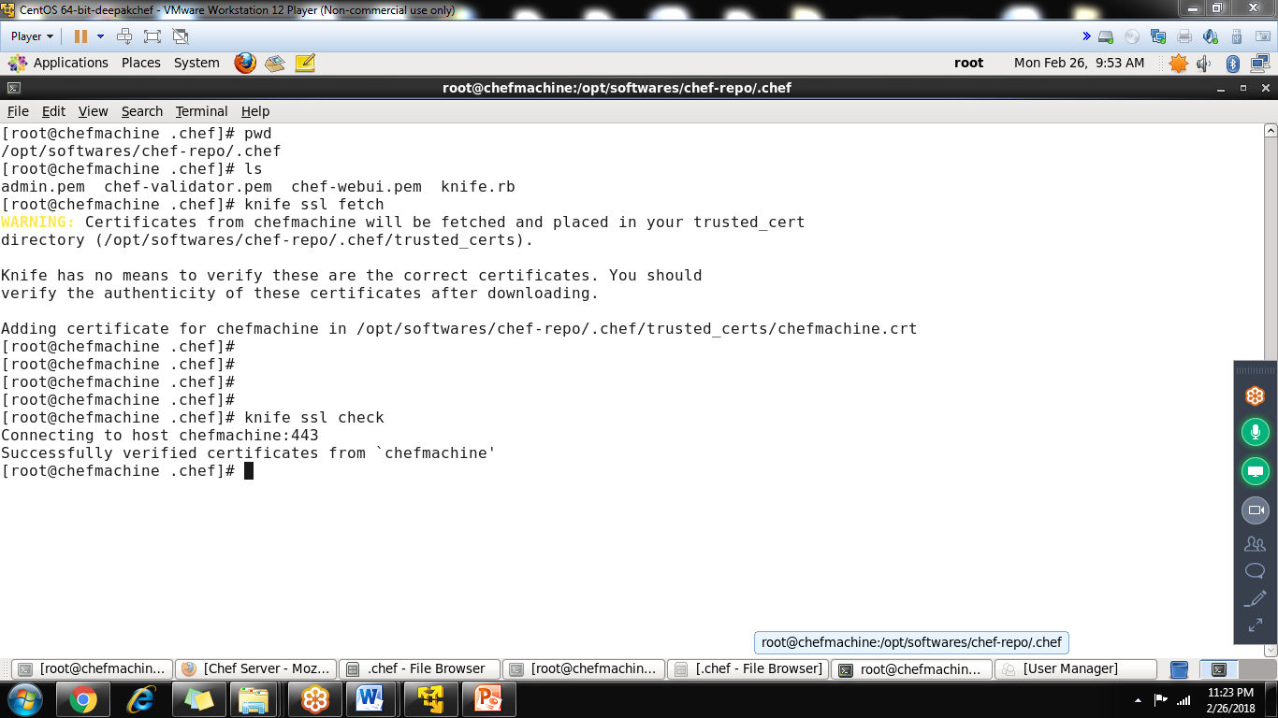

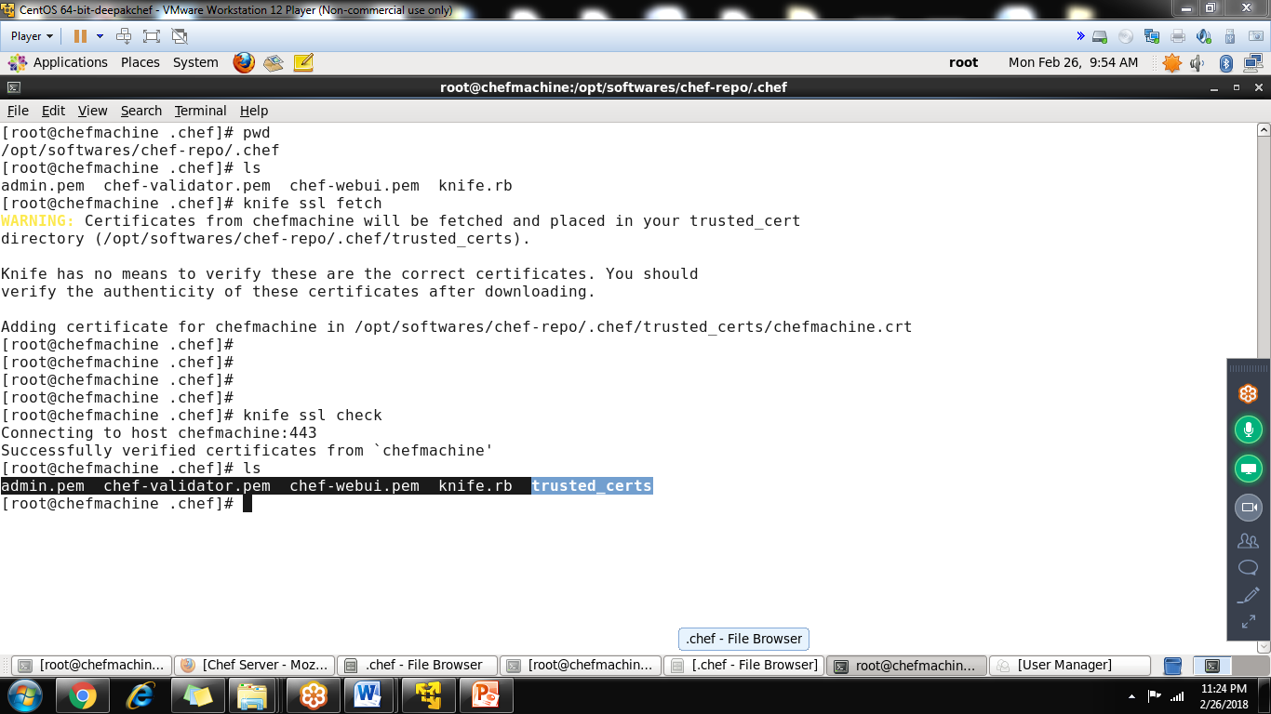

India1.pem file is missing ,so rerun the command

Knife configure –i

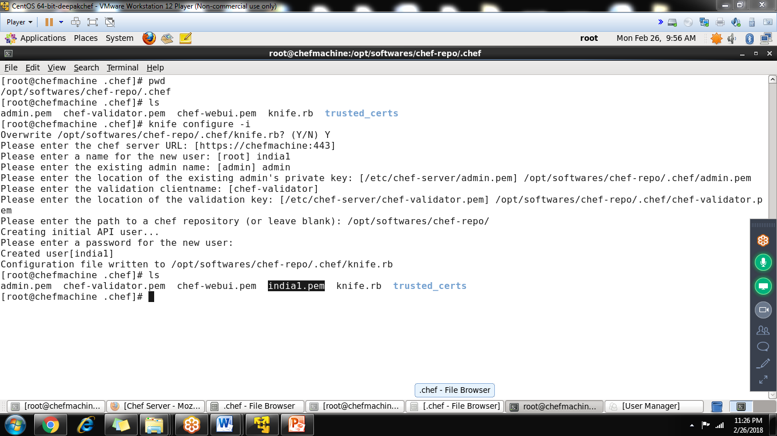

From this workstation to chef server is completed

-----------------------

**Step-4: Installation of Chef Node in Linux same machine**

**Already we installed chef,**

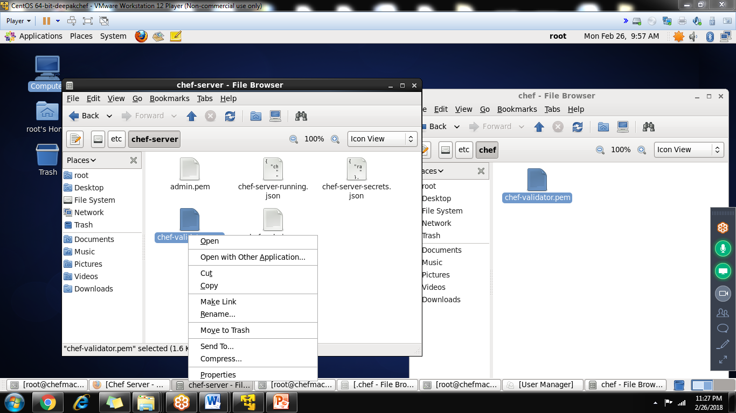

**Copy the /etc/chef-server/chef-validator.pem to /etc/chef**

Create a called client.rb in /etc/chef (purpose of client.rb to add node to chefserver)

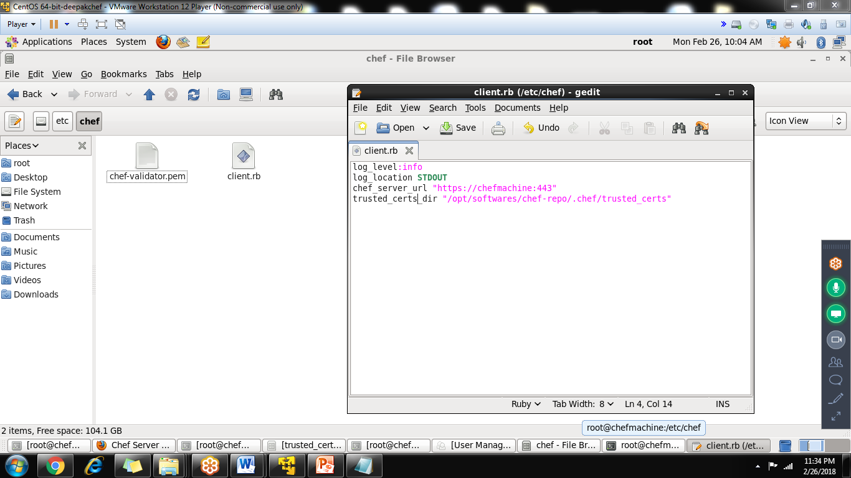

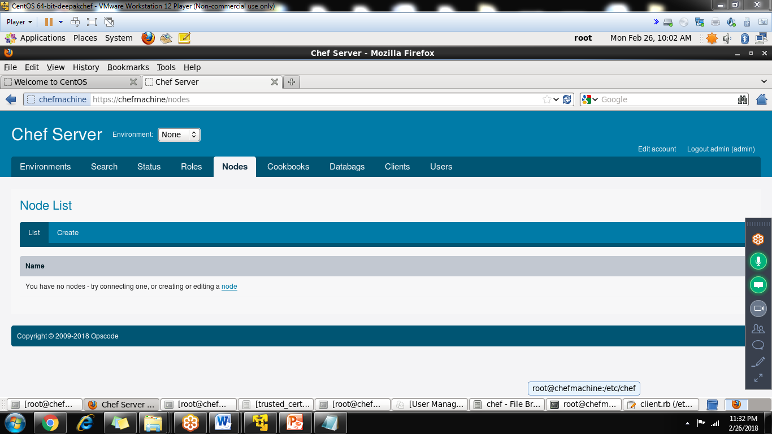

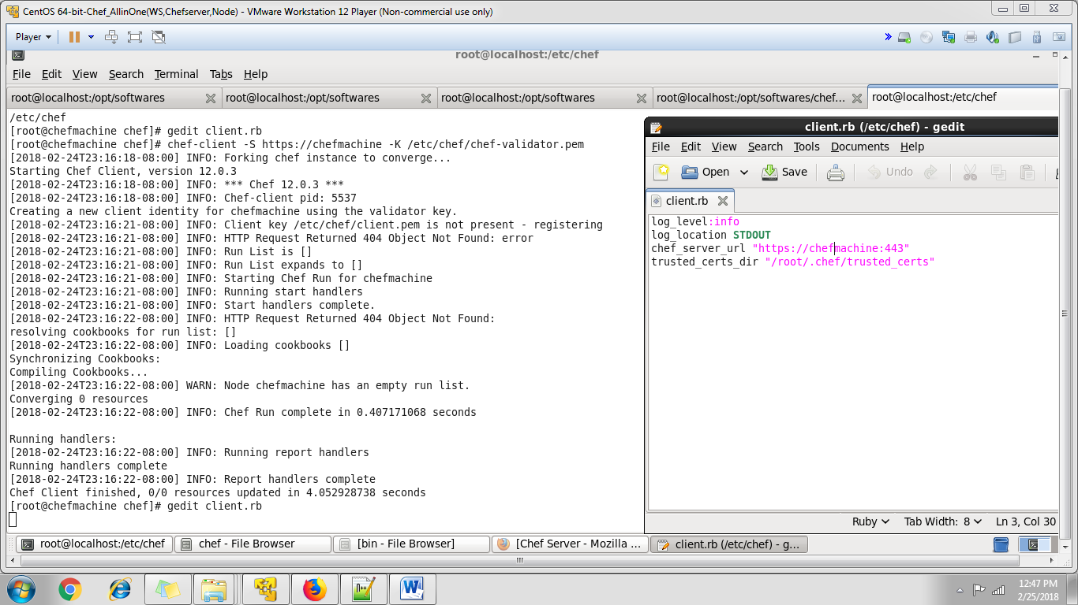

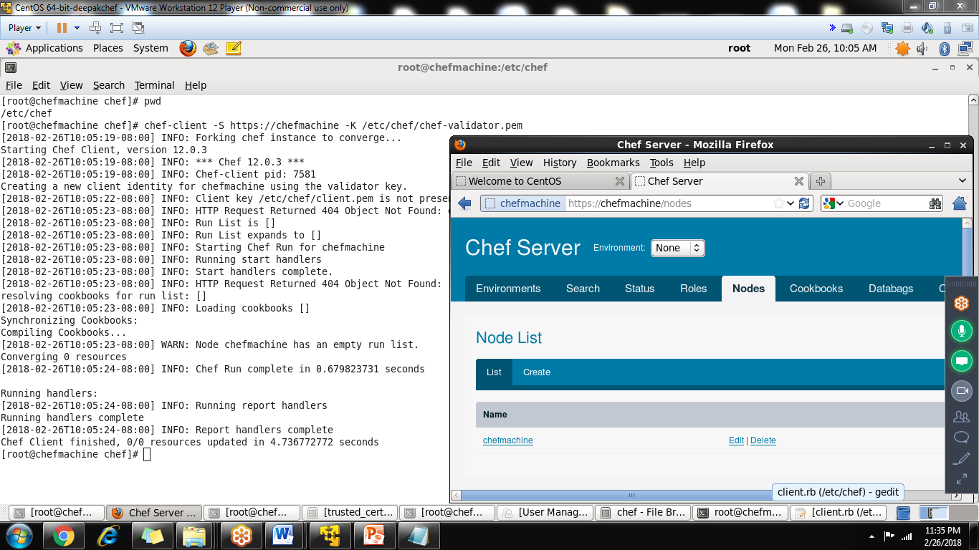

Now you can see node is added under the chef-server console

Knife command to list the users

**** goto /opt/softwares/chef-repo/.chef

Knife user list knife client list

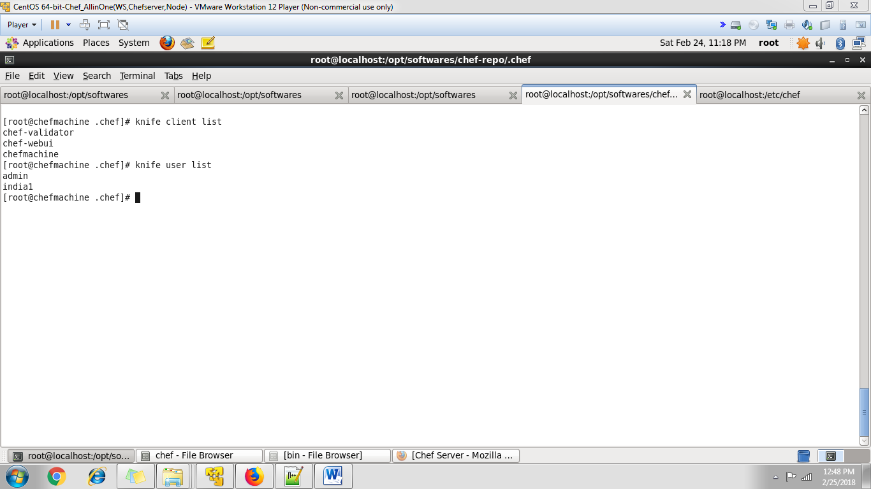

All the setup completed

Step-6: creating cookbook,test and upload to chefserver

Creating cookbooks in workstation

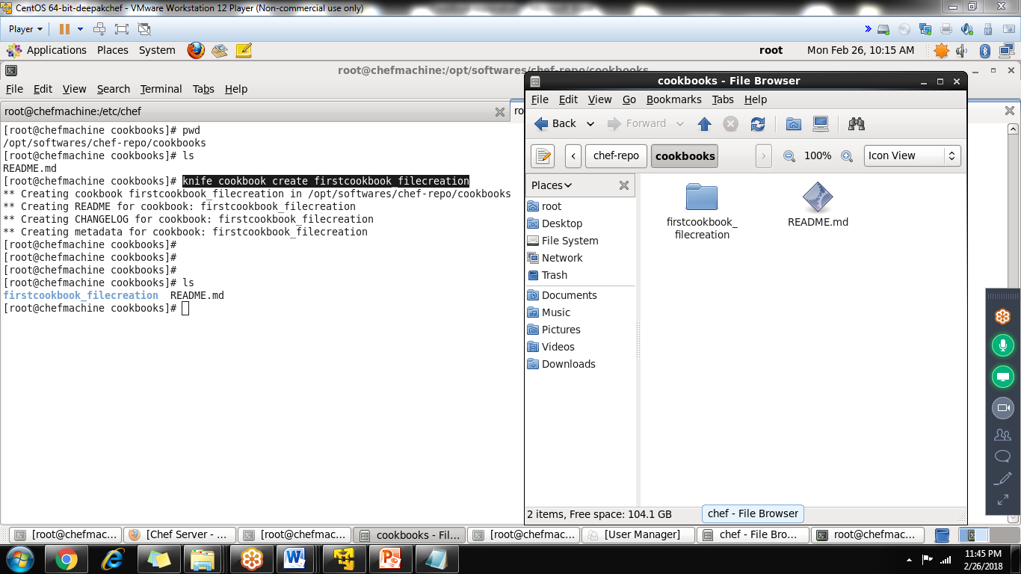

Test the cookbook ruby syntaxes

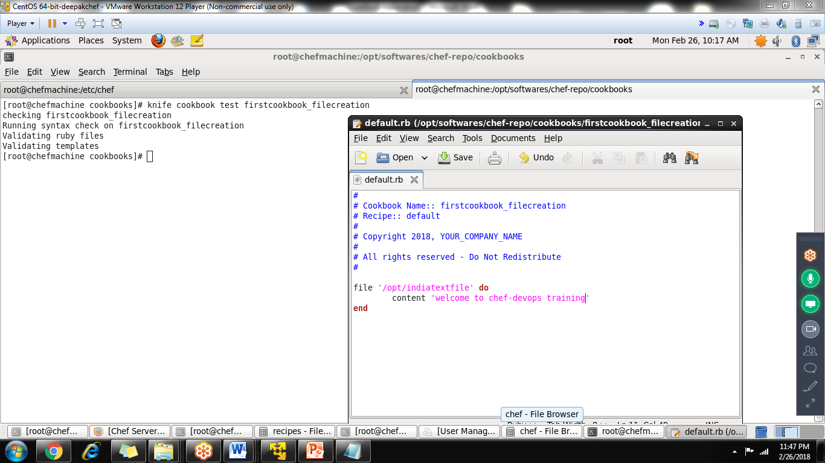

Upload the cookbook to chefserver

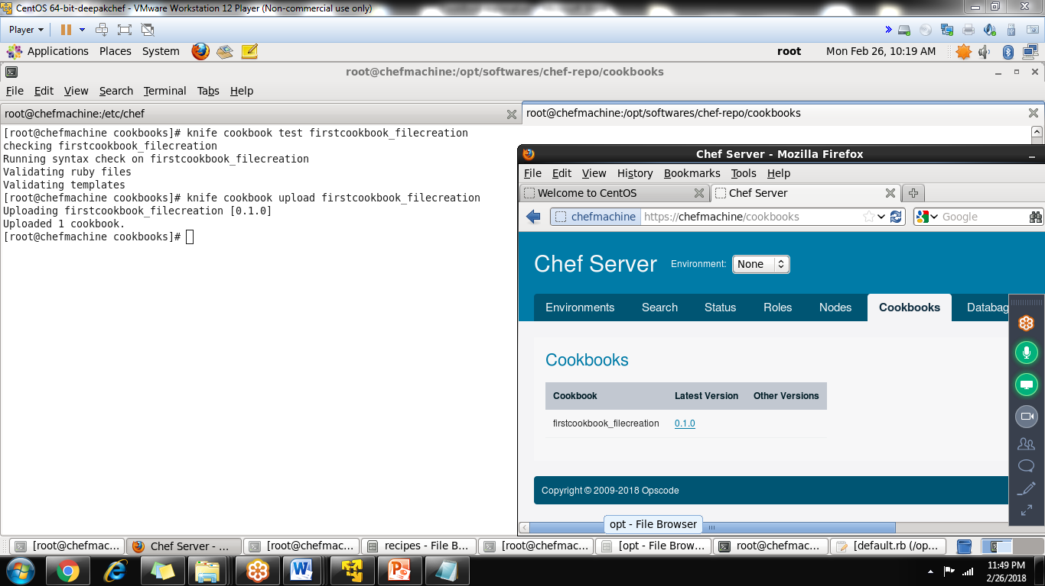

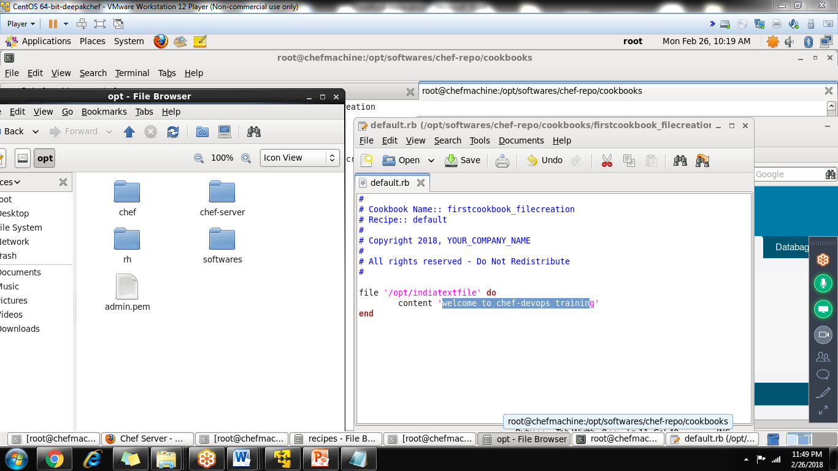

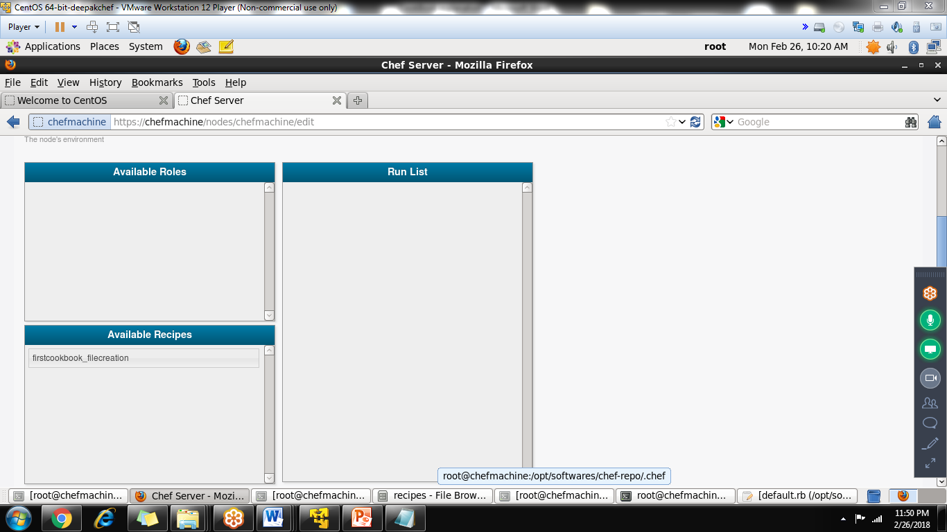

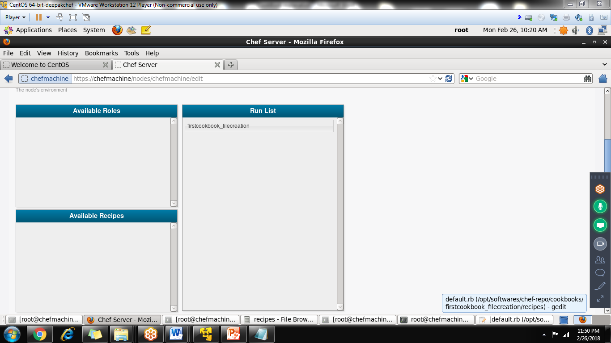

Click savenode

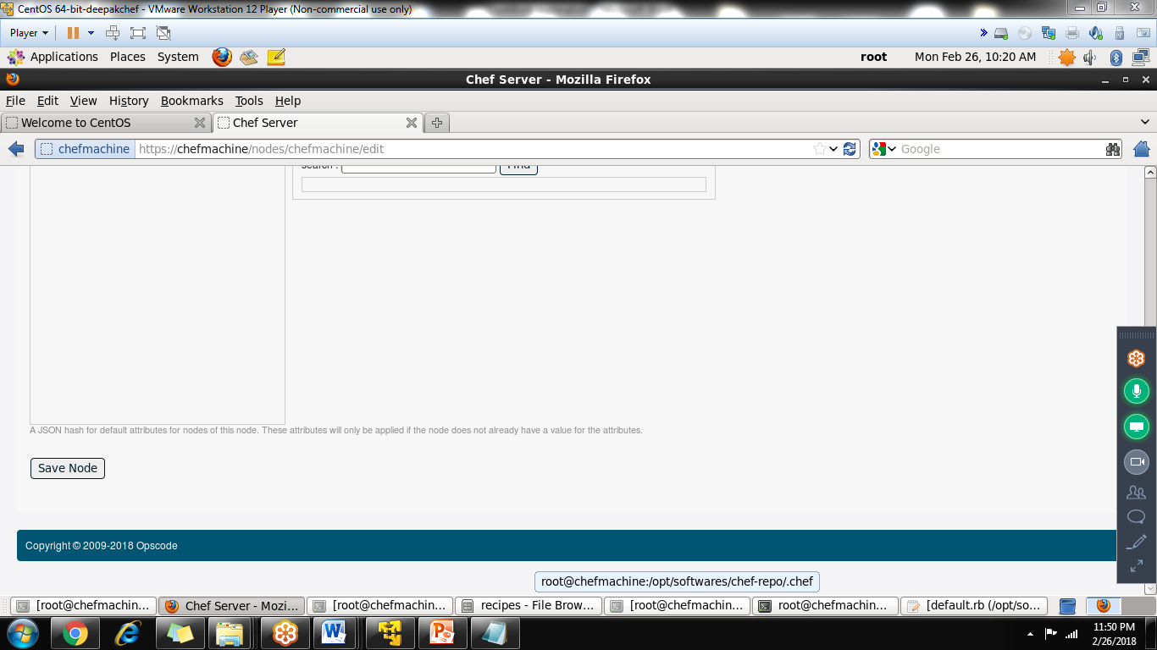

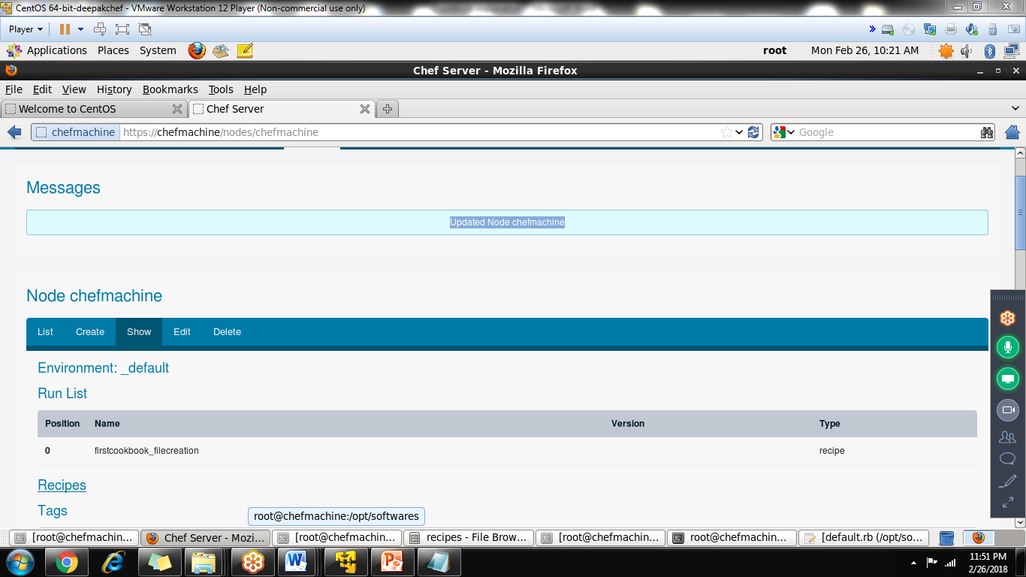

Goto node machine and run the command chef-client

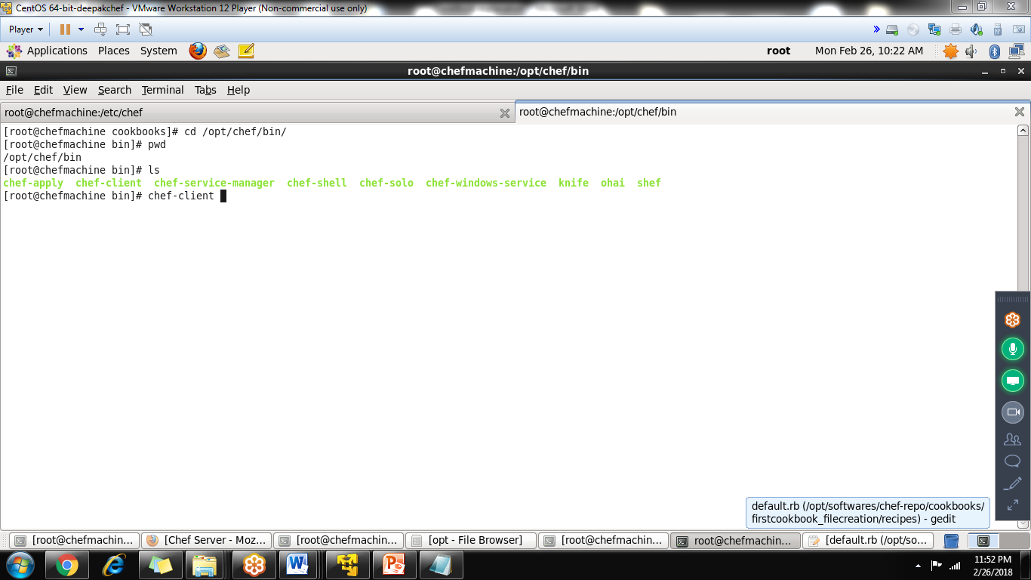

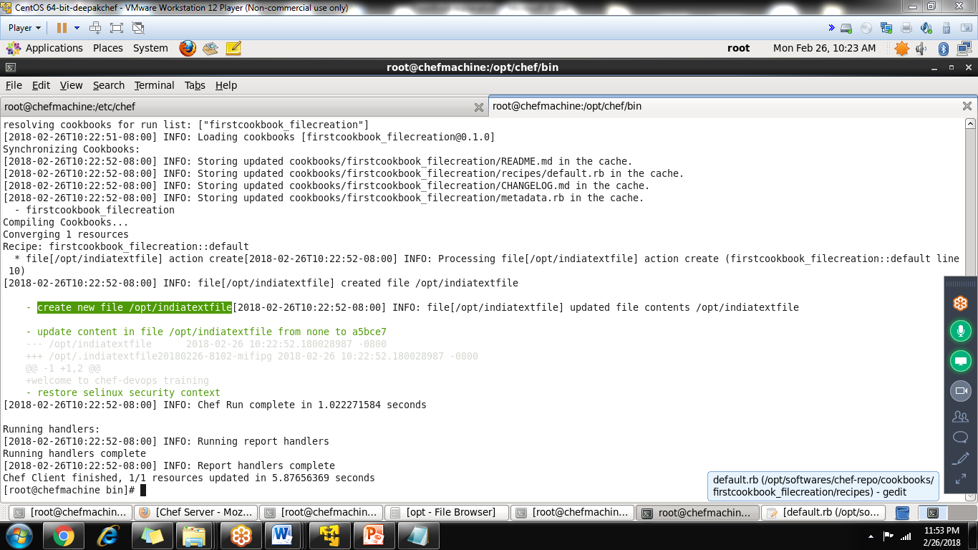

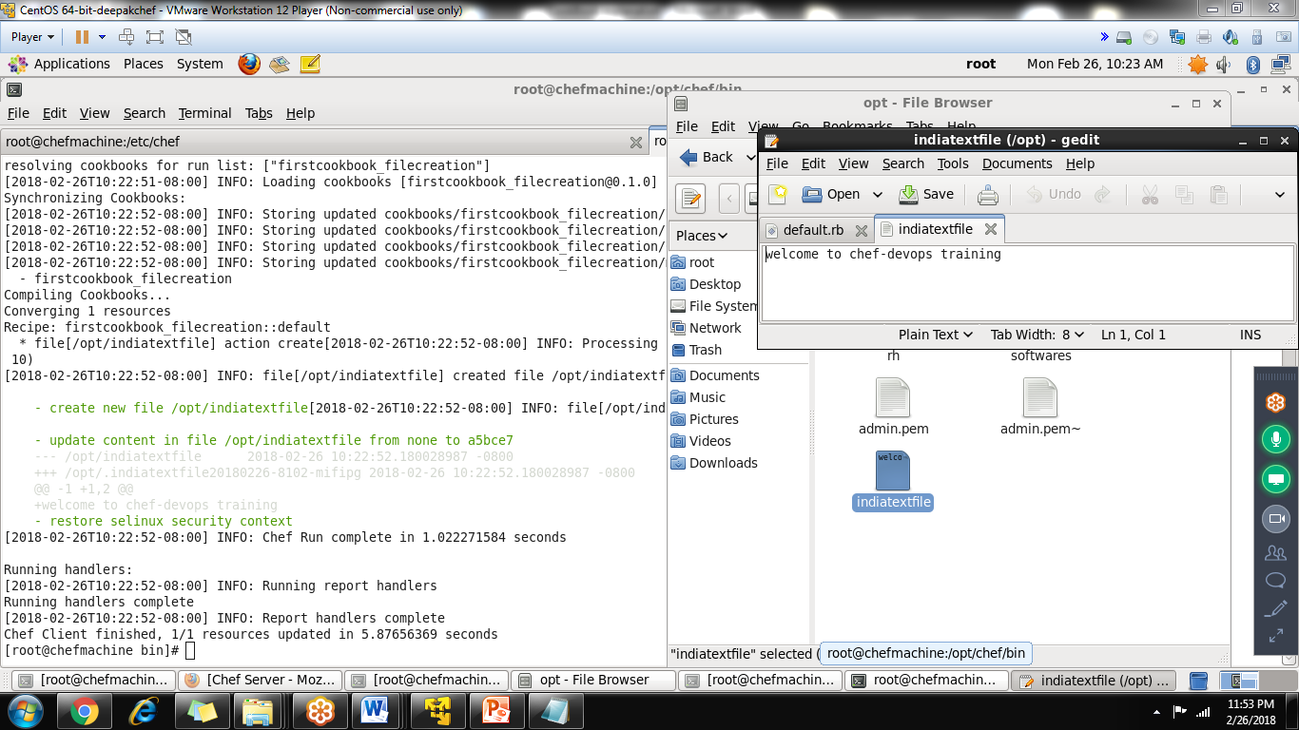

Lab is completed

Model setup info for chef in 3 linux machines

Below are shortcut commands/notes (edit according to ur system/environments)

|  |
| --- |
| in all 3 machines-add the FQDN Names  192.168.80.199 chefwork.testindia.com chefwork  192.168.80.200 chefserver.testindia.com chefserver  192.168.80.201 chefnode.testindia.com chefnode  192.168.126.159 chefserver.testindia.com chefserver  192.168.126.160 chefnode.testindia.com chefnode  192.168.126.161 chefwork.testindia.com chefwork  disable the firewall in all 3 nodes  admin username: root password:redhat  user: root1 password:redhat  -----------------------------------------------------  setting up the chef server  1. install the chef 11.x(stable release)  rpmquery chef-server (to check any chef software is installed or not)  rpm -ivh chef-server-11.1.6-1.el6.x86_64  chef-server-ctl reconfigure  chef-server-ctl status (in 11.x 8 process will come up)  managment console will come automcatically  https://chefserver:443  username: admin  password: it will display  username: admin  password: p@ssw0rd1  step -2 ---- in workstation machine  Chef workstation----install the chef client software  filename: chef-12.0.3-1.x86_64.rpm  rpmquery chef (it shows package not installed)  rpm -ivh chef-12.0.3-1.x86_64.rpm  rpmquery chef  chef-12.0.3-1.x86_64  Now the communication between chefwork and chefserver should be secure  through certificates .pem file  so we need to copy the certificates from chef-server to chef-workstation  Step -3: goto chef server  goto cd /etc/chef-server/  ls (list)  admin.pem  chef-validator.pem  chef-running....json  chef-.....json  chef webui.pem  3 files admin.pem,chef-validator.pem,chef webui.pem needs to copy from chefserver to chef-workstation machine  scp admin.pem root@chef-workstation:  accept----yes  copy  scp chef-validator.pem root@chef-workstation:  accept----yes  copy  scp chef webui.pem root@chef-workstation:  acceptyes-copy  so we will get 3 files admin.pem,chef-validator.pem,chef webui.pem copied to chef-workstation  in root home directory  goto /home/root/  mkdir .chef  copy all 3 .pem to .chef directory  cp admin.pem .chef/  cp chef-validator.pem .chef/  cp chef-webui .chef/  just to check---goto cd .chef/  3 .pem files will present  --------  step -4: prepare communication from chef-workstation to chef-server using knife commands  being in the .chef/ or being in chef directory  check in chef-server user account---- we have user as root1 (not admin user)  in workstation machine,give  knife configure -i  enter  it shows /root/.chef/knife.rb ------just press enter  location of chef server url only------ https://chef-server.testindia.com:443  name of user: root1  name of existing admin : admin  location of admin.pem: /root/.chef/admin.pem  name of chef-validator : chef-validator  localtion of chef-validator : /root/.chef/chef-validator.pem  chef repositry: leave blank (dont type anything)  please enter password for new user: redhat  after entering it may give ssl error  use the command: knife ssl fetch  it will fetch  and try with another command : knife ssl check  it shows sucessfully connected to chef-server:443 (Important)  Now ** once again give the command knife ssl fetch  knife configure -i  enter  it shows /root/.chef/knife.rb ------overwrite the file----yes  location of chef server url only------ https://chef-server.testindia.com:443  name of user: root1  name of existing admin : admin  location of admin.pem: /root/.chef/admin.pem  name of chef-validator : chef-validator  localtion of chef-validator : /root/.chef/chef-validator.pem  chef repositry: leave blank (dont type anything)  please enter password for new user: redhat  output will be: configuration file written to /root/.chef/knife.rb  just to confirm tht  goto /root/.chef/ ls -ltr  admin.pem  chef-validator.pem  chef-webui  root1.pem  knife.rm  trusted_certs  if go inside trusted_certs  chef-server_testindia_com.crt  just to reconfirm process  knife client list (in workstation machine)  chef-validator  chef-wuie  knife user list  admin  root1  so now workstation is configured sucessfully  --------------------------------  step -5: configure the node with chef-server to use certificates  rpmquery chef  rpm -ivf chef-12.0.3-1.x86_64.rpm (chef client)  create the directory called  mkdir /etc/chef  from chef-server we need to copy the all chef-validator.pem file like before  goto chef-server  scp chef-validator.pem (only) root@chef-node:  accept-yescopy  from localmachine  then cp chef-validator.pem to /etc/chef  just to confirm it  goto cd /etc/chef ls -ltr  chef-validator.pem (certificate signature of server)  being in node machine-fetch the ssl connection  knife ssl fetch -s https://chef-server.testindia.com (no ports required)  ......adding certicate......  goto cd /root/.chef/trusted_certs  ls -ltr  chefserver_testindia_com.crt  just to check again---- knife ssl check -s https://chef-server.testindia.com  ** sucessfully verified.....  Next goto cd /etc/chef  create a file called vim or gedit client.rb ****  log_level:info  log_location STDOUT  chef_server_url "https://chef-server.testindia.com:443"  trusted_certs_dir "/root/.chef/trusted_certs"  save the file  cat client.rb  it shows the file we created  **** to make node to join with chef-server,use the command  use the below command  chef-client -S https://chef-server.testindia.com -K /etc/chef/chef-validator.pem  chef-client -S https://chefserver -K /etc/chef/chef-validator.pem  i.e: join to server using this certificate  output will be chef client finished.  to confirm  goto the chef-workstation machine  in commandline  knife client list  chef-validator  chef-webui  chefnode.testindia.com  knife user list  admin  root1  Again to check-----goto web-interface in chef-server  https://chef-server.testindia.com:443  username: admin  password: test1234 display there itself check  once you login-change the password ---redhat  goto the nodes-----you can see nodename there**  ---------------------------------------  5. creating cookbook and test from work station  goto cd /var/chef/ check for cookbooks folder  use the command called knife cookbook create amazon1  it will create a cookbook called amazon1 in /var/chef/cookbooks  goto /var/chef/cookbooks/amazon1  it shows full structure of cookbooks created  gedit /var/char/cookbooks/amazon1/receipes/default.rb open it  just writing  file '/etc/amazonindia' do  content 'Testcookbook'  end  save it---just we are trying to create a file in name of /etc/amazon1  before applying----better to check the syntax using below command  knife cookbook test amazon1 (it will check for syntax errors)  command to upload the cookbook/receipes are  knife cookbook upload amazon1  **it will shows uploaded  knife cookbook list  amazon1  **  goto managment console-----click the cookbooks----we can see amazon1  again goto Node-----click on the chef-node----EDIT BUTTON  Available receipes------>drag to----->run list  Click Save Here----Last bottom of page  final goto chef-node machine  try cat /etc/amazon1 -----nothing will come---because its not applied  ** run the command chef-client  in last we can see the file created/string value  cat /etc/amazon1  file created----open welcome to chef.....string value |